Newsletter | E-mail Template: Flu Shot Clinic Schedule

Year Flu Shot Clinic Schedule

Department is sponsoring flu shot clinics for Company Name employees and their families. The clinics are part of Company Name’s proactive approach to flu prevention and are consistent with the company’s pandemic planning efforts.

Vaccination remains the cornerstone of preventing influenza, a contagious respiratory disease caused by different viruses infecting the nose, throat and lungs. The Current Year vaccine addresses the virus strains expected to be the most common during the upcoming flu season. The virus strains expected to circulate in the upcoming flu season include:
- Update annually based on CDC’s website (www.cdc.gov)

The Center for Disease Control and Prevention estimates 5-20% of the US population develops influenza each year. This results in more than 200,000 hospitalizations from related complications. Flu seasons are unpredictable and can be severe, with annual influenza-related deaths ranging from a low of about 3,000 to a high of 49,000 people in the US.

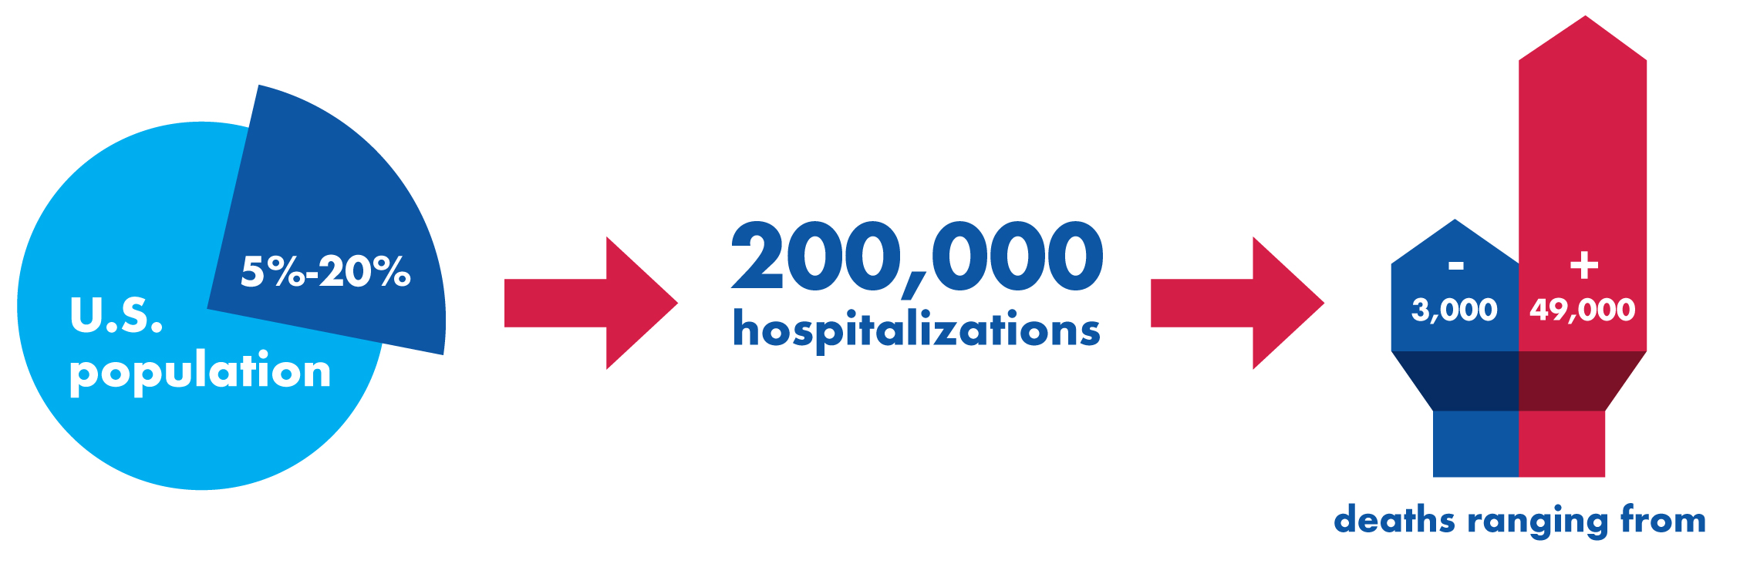

Flu shots are available to persons age 18 and older. Pregnant women are not eligible.

Vendor will administer flu shots. Costs is $XX, accepted method of payment (i.e., cash, check, etc.)
- Location of clinic
- Day of week, Month, Date
- Time of operation

Schedule appointments by contacting company employee, email address and phone info.
Include other company locations as necessary.

